select color, avg(qty) as average, sum(qty) as total from sp join p on sp.pno = p.pno group by color

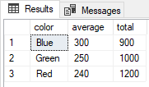

select distinct p.pno, pname from p join sp on p.pno = sp.pno where sp.sno not in (select distinct sp.sno from sp join sp sp2 on sp.sno = sp2.sno and sp.sno = 'S1')

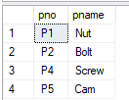

select p.pno, p.pname, sp.sno, s.sname from p join sp on p.pno = sp.pno join s on s.sno = sp.sno where sp.sno in (select s.sno from s join sp on s.sno = sp.sno where city = 'London')

